**Space Attack**

A scratch game

This game will have 3 sprites:

1. 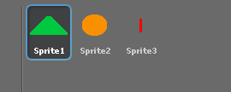Your spaceship
2. And enemy
3. A laser/missile

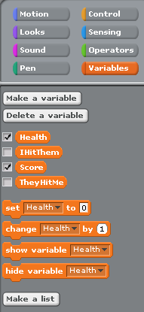We start off by setting up our broadcasts and variables.

Broadcasts for controlling the game start and variables for health score and hi detection

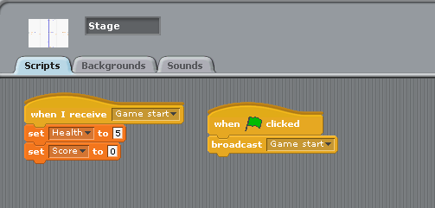

Note how the broadcasts are set up in the stage script area.

Space Ship

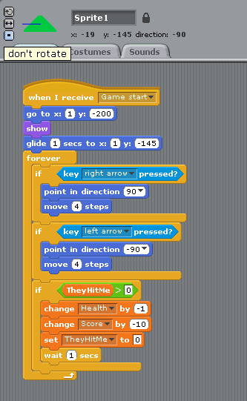Now we set up controls for our space ship.

We set the spaceship to not rotate.

We also set up how it enters the game from the bottom of the screen and glides up for 1 second.

Here we have what happens if we get hit by an enemy. We lose health, score and we get frozen in place for 1 second

Enemy

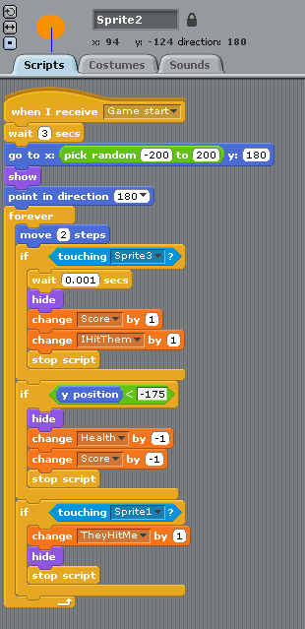Here is the script for our enemy.

He has a wait timer for when he appears.

He will appear in a random area at the top of the screen.

He will head down towards us.

If he gets hit by our laser then we get points.

If he reaches the bottom of the screen we lose some points.

If he touches us we lose health and score and get frozen (see space ship)

Laser

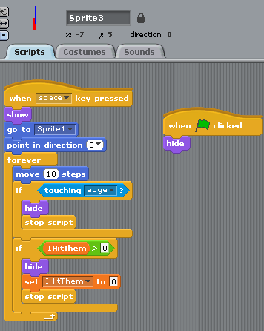

Here is our laser.

It’s different to the space ship and enemy in that It start whenever we hit space.

This allows us to re-use it once is either hit and edge or an enemy.

If an enemy gets hit by it the enemy changes *IHitThem* to 1. Which tells our laser that he hit something and should stop and hide.

This method allows us to have multiple enemies of different shapes, sizes and colours that the laser can still hit.

Once you have done this you have completed a basic game

Improvements

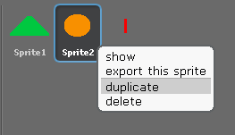First of all we can start adding more enemies really quickly.

By duplicating we also duplicate the code on the enemy as well.

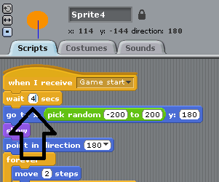We just have to make sure that the enemies spawn at different times

We can improve how our game looks as well. For my completed game I used a number packs, sprites and backgrounds from opengameart.org (links included in resources).

Resources

Graphics from: <http://opengameart.org>

Space ship art from: <http://opengameart.org/content/space-game-starter-set>

Menu art from: <http://opengameart.org/content/free-ui-asset-pack-1>